Mohamad Imam Firdaus (13218025)

EL2008 - Pemecahan Masalah dengan C

Teknik Elektro - Sekolah Teknik Elektro dan Informatika ITB

1. Penurunan Rumus

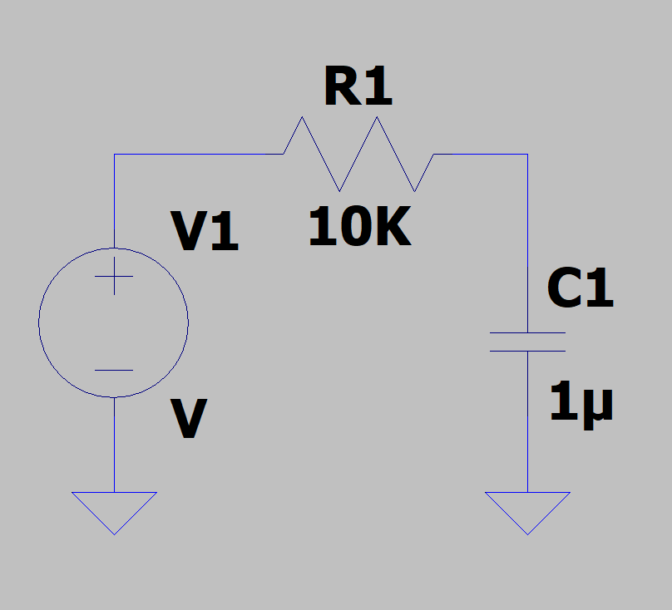

Ic = Ir

Ir = Vr/R

Vs – Vr – Vc = 0

Vr = Vs – Vc

Ic = C dvc/dt

Ir = C dvc/dt

Vr/R = C dvc/dt

(Vs – Vc) dt /RC = dvc

V1c = V0c + dvc

V1c = V0c + (Vs – Vc) dt /RC

dt ≈ Δt

τ = RC

V1c = V0c + (Vs – Vc) Δt / τ

1. Flowchart

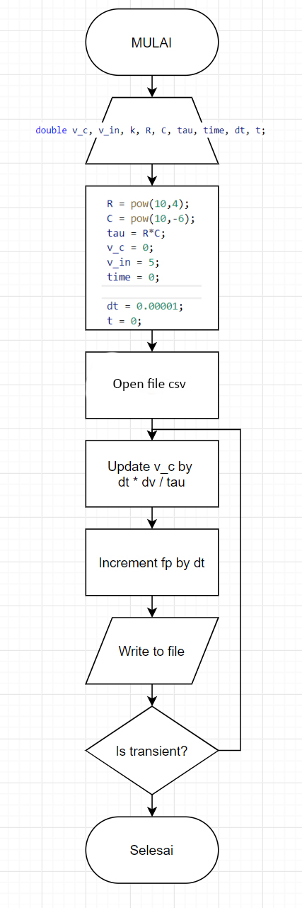

1. Source code

|  |
| --- |
| #include <stdio.h>  #include <math.h>  double v_c, v_in, k, R, C, tau;  double time, dt, t;  int main(void)  {  R = pow(10,4);  C = pow(10,-6);  tau = R*C;  v_c = 0;  v_in = 5;  time = 0;  dt = 0.00001;  t = 0;  FILE *fp;  fp = fopen("voltage.csv", "w+");  fprintf(fp,"t,Vc\n");  while(v_c < 0.95*v_in){  v_c += dt * (1/tau) *(v_in - v_c);  t += dt;  fprintf(fp, "%lf,%lf\n", t, v_c);  }  fclose(fp);  return 0;  } |

1. Hasil Eksekusi

